
Syndax at JPM Healthcare Conference 2026; highlighted plans for new PoC study in 1L KMT2Ar fit AML
Company: Syndax  Drug: Revuforj (revumenib; menin-MLLi) | Date: Jan 12, 2026  Source(s): Presentation, Press Release, Webcast
What happened:
- Syndax presented at JPM Healthcare Conference 2026, and highlighted Revuforj’s accelerating uptake following R/R NPM1m approval (Oct 2025), alongside expanding use in post-transplant maintenance and combinations
- It positioned the 1L AML program as a key value driver for sustained growth through 2026, and discussed key priorities for 2026:
  - To advance global enrollment in the pivotal Ph 3 EVOLVE-2 (revumenib + Ven + Aza, 1L NPM1m or KMT2Ar unfit AML) and Ph 3 REVEAL-ND NPM1 (1L NPM1m fit AML, revumenib + 7+3) studies (reiterated)
  - To initiate a planned Ph 2 RAVEN (revumenib + Ven + Aza, 1L KMT2Ar fit AML) study (new guidance)
- Commentary during Q&A reinforced confidence in R/R NPM1m leadership, R/R KMT2Ar penetration upside, and continued revenue acceleration

Approval timelines:
 | US | EU
R/R NPM1m AML  (Ph 3 AUGMENT-101; revumenib) | Oct 24, 2025  (Approved) | NA  (While development plans in the EU remain unclear, Syndax recently partnered with WODA for expanding Revuforj access in Eurasia, Central and Southeast EU)
1L NPM1m or KMT2Ar unfit AML  (Ph 3 EVOLVE-2; revumenib + Ven + Aza) | 3Q 2028 (AA)  (CI assumptions based on CR data readout in 2028; no changes to timelines) | 1Q 2031  (CI assumptions based on Dec 2029 PCD; no changes to timelines)
1L NPM1m fit AML  (Ph 3 REVEAL-ND NPM1; revumenib + 7+3) | 3Q 2028 (AA)  (Aggressive CI assumptions based on in-class analogues; no changes to the timelines) | 3Q 2030  (CI assumptions based on Jun 2029 PCD; no changes to timelines)

Impact (CI PoV): MEDIUM
- JPM IR call underscored Syndax’s strategic pivot from defending Revuforj’s safety profile in R/R AML to aggressively framing it as a future 1L menin inhibitor leader, leveraging its first-in-class narrative to justify expansion into 1L unfit and fit AML

Why it matters (CI Insights in blue italics):
Clinical and Medical Strategy:
- 1L AML
  - A broad 1L development strategy is underway, anchored by the pivotal Ph 3 EVOLVE-2 (revumenib + Ven + Aza, 1L NPM1m or KMT2Ar unfit AML) and Ph 3 REVEAL-ND NPM1 (1L NPM1m fit AML, revumenib + 7+3), designed to support potential accelerated and full approvals
    - The management highlighted the advancement of global enrollment in these trials
  - Syndax has planned to initiate Ph 2 RAVEN (revumenib + Ven + Aza, 1L KMT2Ar fit AML) study as a lower-intensity alternative to intensive chemotherapy
    - The company noted that the strategy with RAVEN study is to deliver 1L efficacy with a less intensive, better-tolerated regimen that avoids the toxicity of high-dose chemotherapy
  - Management emphasized the goal of positioning Revuforj as a “targeted anchor” therapy across the AML treatment continuum, from R/R to 1L
- For the first time, the company explicitly positioned itself as aiming to be “first to the 1L with a menin inhibitor, building on a long history of firsts with Revuforj” as a strategic messaging expansion beyond R/R AML
- Syndax is clearly pursuing expansion into fit AML population across both NPM1m and KMT2Ar. However, the development maturity diverges significantly, with NPM1m supported by an ongoing Ph 3 study (REVEAL-ND NPM1), while KMT2Ar remains at an earlier stage with only Ph 2 development, introducing uncertainty around timelines and suggesting a likely focus on NCCN guidelines inclusion rather than label expansion
- Post-transplant maintenance AML
  - Transplant enablement has improved meaningfully: ~33% of KMT2Ar patients now proceed to transplant vs ~5% historically in late-line settings, expected to rise toward ~50% as experience grows
  - Syndax further stated plans to continue publication and presentation of industry-leading clinical data of revumenib in post-maintenance settings, possibly in 2026

Commercial and Market Dynamics:
- R/R AML
  - Time from prescription to patient access is ≤4 days, with ~97–98% reimbursement achieved in KMT2Ar and rapidly building coverage in NPM1m, where physicians are increasingly using Revuforj in earlier R/R settings (2L–3L)
  - Syndax highlighted that NPM1m approval has ~tripled the eligible patient pool, materially expanding Revuforj’s commercial opportunity
    - Early total prescriptions (TRx) data indicate rapid uptake and strong physician enthusiasm following label expansion
    - The management stated it is too early to provide granular NPM1m guidance, noting that transplant rates, treatment duration, and competitive dynamics are still evolving
    - Despite emerging competition, Syndax expects to dominate the NPM1m segment, driven by first-mover advantage and best-in-class profile
  - Off-label combination use (with Ven, HMA, chemo) is expanding in real-world practice, supporting broader integration into AML treatment pathways
  - During the Q&A, it was highlighted that physicians were using Revuforj off-label for NPM1m setting prior to approval, supporting rapid on-label adoption post-approval
  - During Q&A, the management noted that it sees no structural barriers to increasing KMT2Ar penetration beyond current levels, citing lack of approved alternatives and poor outcomes with standard therapies
- As expected, the company reinforced Revuforj’s leadership narrative by anchoring its positioning being “first-to-market”, “best-in-class” and the “only approved in adults and children”, underscoring its differentiated and durable competitive advantage

Tell me more:
Financial Highlights:
- Strong balance sheet, increasing contributions from Revuforj (and Niktimvo), and a stable expense outlook expected to drive path to profitability
- FY 2025 preliminary revenue of ~$125M, exceedingly first-year benchmarks of prior AML targeted therapies
- ~1,150 TRx observed in 4Q 2025 (QoQ ~+35%), with stable inventory levels, indicating demand-driven growth
USD | 4Q 2025 (Global)
Cash, cash equivalents, and marketable securities | $394 M (unaudited)

Global sales (USD) | Revuforj Net Sales
4Q 2025 | ~$44 M (unaudited)
3Q 2025 | $32.0 M
QoQ change | 38%
FY 2025 | ~$125 M (unaudited)

- 2026 Outlook (across LoTs):
  - Revenue acceleration expected to continue through 2026, supported by:
    - Growing R/R NPM1m adoption
    - Continued KMT2Ar penetration
    - Longer treatment durations via maintenance use
    - Early migration toward frontline settings
  - The management highlighted 4Q 2025 performance as an early indicator of NPM1m-driven growth layered onto a stable KMT2Ar base, reinforcing confidence in 2026 momentum

Relevant Slides

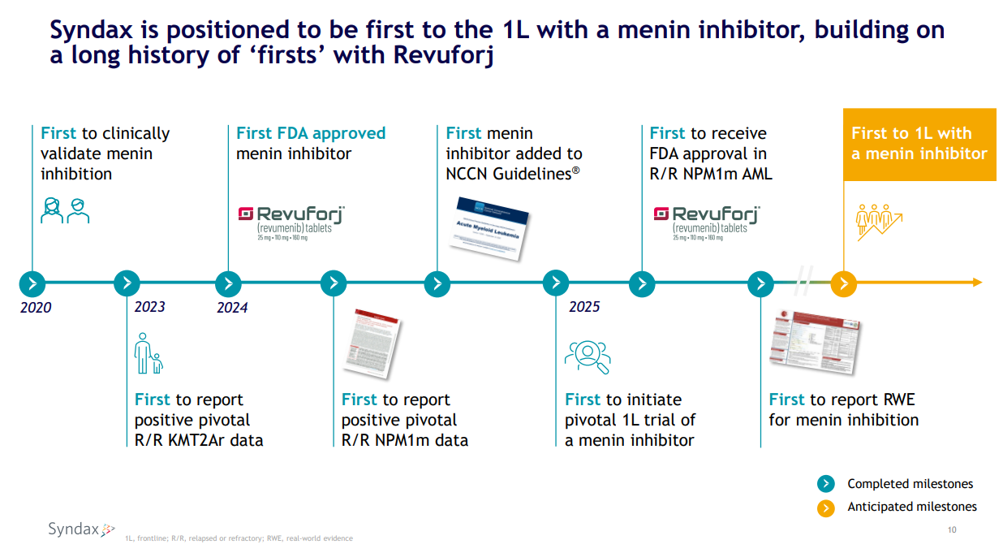

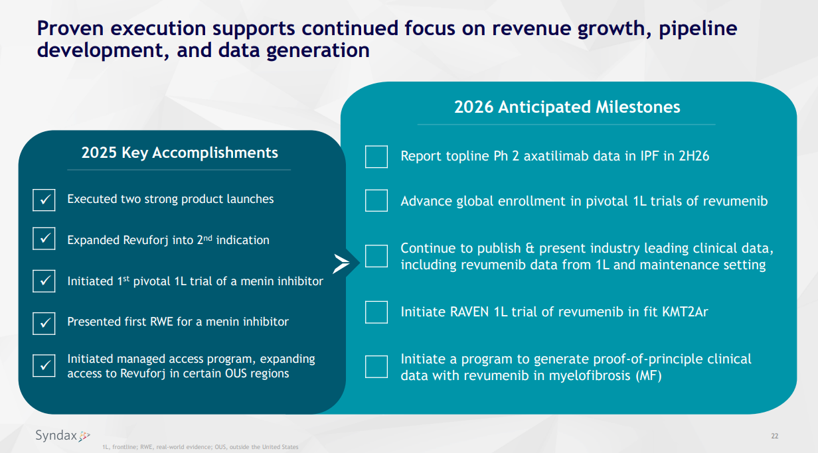

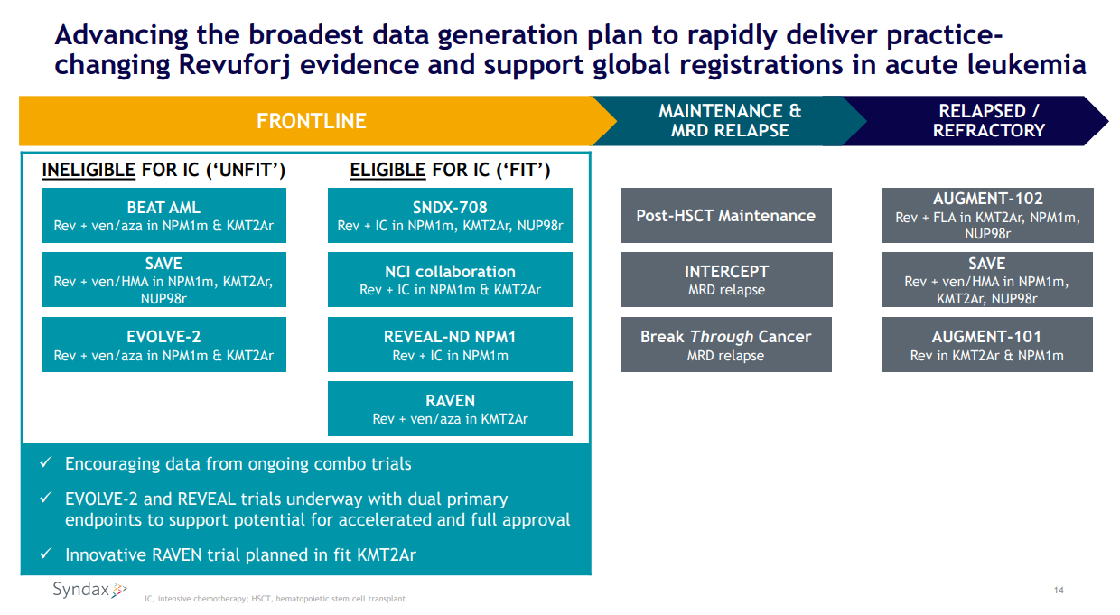

For questions, please reach out to:
International / Affiliates: Harjit Bajwa
US: Richa Sharma

Invite your colleagues to CI Edge | Manage Email Preferences | Unsubscribe

This document/email contains competitive intelligence collected via an approved competitive intelligence supplier working on behalf of AbbVie. We collect competitive intelligence consistent with industry standards and AbbVie policy. Not for field distribution. Please reach out to APEX/IMABI, Legal, or OEC teams with any questions.

